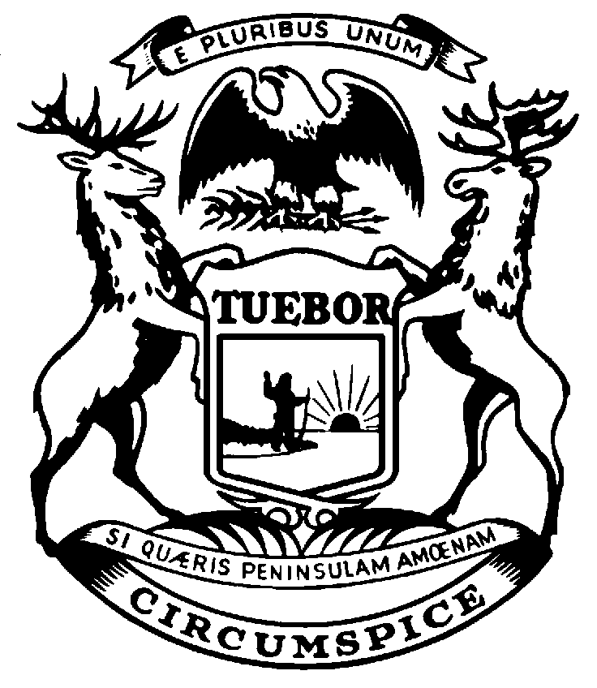
NICK LYON
director
RICK SNYDER
governor
State of Michigan
department of HEALTH AND human services
Lansing

Office of Child Support Central Operations
P.O. Box 30744
Lansing, MI 48909-8244
Telephone: 517-241-8112
Fax: 517-455-7978

Addendum to Notice of Lien and Levy (FEN340) Dated:
Account Number(s): Any and All Applicable Accounts

Obligor’s First Name: Obligor’s Last Name: Obligor’s Social Security #:

Docket:

Arrears:

Custodial Parent Name:

Order Date:

County Name:

Docket:

Arrears:

Custodial Parent Name:

Order Date:

County Name:

Docket:

Arrears:

Custodial Parent Name:

Order Date:

County Name:

Total Arrears: $

